Project: Analyze Customer Behavior
We are going to analyze the entire customer lifecycle: acquisition, conversion, customer activity, retention and churn.
acquisition is the stage when the customers learn more about the company's offerings from visits to the website, in an online business, this stage ends with customer registration on the website.
Conversion is the stage where customers purchase a product or service.
Retention. Now that a new customer has been acquired, the focus is to help the customer derive satisfaction and value from the product and services. In this stage, you can measure customer activity: how much they purchase, how often they use your product, etc.
The final stage in the customer lifecycle is customer churn. Inevitably, customers will stop using your product
Data Model
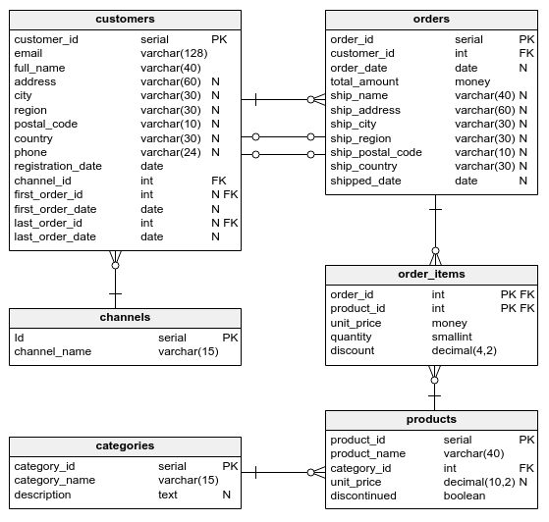
Explanation about relationship
- Customers and Orders: A customer can have many orders, but an order belongs to only one customer. This is represented by the foreign key customer_id in the orders table. [One-to-Many Relationships]
- Orders and Order Items: An order can have many order items, but an order item belongs to only one order. This is represented by the foreign key order_id in the order_items table. [One-to-Many Relationships]
- Products and Categories: A product belongs to only one category, but a category can have many products. This is represented by the foreign key category_id in the products table. [One-to-Many Relationships]
- Channels and Customers: A customer can register through multiple channels, and a channel can have many registered customers. [ Many-to-Many Relationships]
List of tables
- Customers
  - It contains information about customers.
  - It is used to store and manage customer details for communication, analysis, and order tracking.
- Orders
  - It contains details of customer orders.
  - It is used to track order details, including who placed the order, where it should be shipped, and the overall cost.
- order_items
  - It details the products included in each order.
  - To manage and track the specific products within an order, allowing for detailed analysis.
- Products
  - Contains information about the products available for sale.
- Categories
  - Contains information about product categories.
- Channels
  - Details the channels through which customers are acquired.
  - Example:
    - Social
    - Referral
    - Email
    - Paid search
    - Etc.
Description About Attributes
Customers
- customer_id
  - Unique identifier for each customer.
  - Type: int
- Email
  - The email address of the customer.
  - Type: String
- full_name
  - The full name of the customer.
  - Type: String
- Address
  - The customer's street address
  - Type: String
- City
  - The city where the customer resides.
  - Type: String
- Region
  - The region, state, or province where the customer resides
  - Type: String
- postal_code
  - The postal or ZIP code for the customer's address
  - Type: String
- Country
  - The country where the customer resides
  - Type: String
- Phone
  - The customer's phone number, used for communication and verification
  - Type: String
- registration_date
  - The date when the customer registered.
  - Type: Date
- channel_id
  - A reference to the channel through which the customer was acquired.
  - Type: Int (Foreign Key)
- first_order_id
  - The unique identifier of the customer's first order.
  - Type: int
- first_order_date
  - The date when the customer placed their first order.
  - Type: date
- last_order_id
  - The unique identifier of the customer's most recent order.
  - Type: int
- last_order_date
  - The date when the customer placed their most recent order.
  - Type: date
Orders
- order_id
  - A unique identifier for each order.
  - Type: int
- customer_id
  - References the unique identifier of the customer
  - Type: int (foreign key)
- order_date
  - The date when the order was placed.
  - Type: date
- total_amount
  - The total monetary value of the order.
  - Tyoe: decimal
- ship_name
  - The name of the person or entity to whom the order is being shipped.
  - Type: string
- ship_address
  - The street address where the order is to be delivered
  - Type: String
- ship_city
  - The city where the order is to be delivered
  - Type: string
- ship_region
  - The region, state, or province where the order is to be delivered
  - Type: String
- ship_postal_code
  - The postal or ZIP code for the shipping address
  - Type: string
- ship_country
  - The country where the order is to be delivered.
  - Type: string
- shipped_date
  - The date when the order was shipped.
  - Type: date
products
- product_id
  - A unique identifier for each product.
  - Type: int
- product_name
  - The name of the product.
  - Type: string
- category_id
  - References the unique identifier of the category.
  - Type: int
- unit_price
  - The price of a single unit of the product.
  - Type: decimal
- Discontinued
  - Indicates whether the product is still available for sale.
  - Type: tinyint
order_items
- order_id
  - A unique identifier for each order
  - Type: int
- product_id
  - References the unique identifier of the product being ordered.
  - Type: int
- unit_price
  - The price per unit of the product at the time of the order
  - Type: decimal
- quantity
  - The number of units of the product being ordered.
  - Type: int
- Discount
  - The discount applied to the product.
  - Type: decimal
categories
- category_id
  - A unique identifier for each category.
  - Type: int
- category_name
  - The name of the category.
  - Type: string
- Description
  - A detailed description of the category.
  - Type: text
channels
- Id
  - A unique identifier for each channel.
  - Type: int
- channel_name
  - The name of the channel.
  - Type: string
Questions
- How many customers registered in the first six months of 2017? Name the column registration_count.

- Show the number of registrations in the current week. Name the column registrations_current_week.

- Create a report containing the 2017 monthly registration counts. Show the registration_month and registration_count columns. Order the results by month.

- Find the registration count for each month in each year. Show the following columns: registration_year, registration_month, and registration_count. Order the results by year and month.

- Write an SQL query to find the number of customer registrations per year for each channel.

- Write an SQL query to find the number of customer registrations per year for organic search channel.

- Create a report to show the weekly counts of registration in 2017, based on the customer country. Show the following columns: registration_week, country, and registration_count. Order the results by week.

- Among customers registered in 2017, show how many made at least one purchase (name the column customers_with_purchase) and the number of all the customers registered in 2017 (name the column all_customers).

- Find the lifetime conversion rate among customers who registered in 2017. Show the result in a column named conversion_rate. Round the result to four decimal places.
- Find the conversion rate for each customer channel. Show the channel_name and conversion_rate columns. Display the conversion rates as percentages rounded to two decimal places.

- Create a report showing conversion rates in monthly basis. Display the conversion rates as ratios, rounded to three decimal places. Show the following columns: year, month, and conversion_rate. Order the results by year and month.

- Create a report containing the conversion rates for weekly registration in each registration channel, based on customers registered in 2017. Show the following columns: week, channel_name, and conversion_rate. Format the conversion rates as percentages, rounded to a single decimal place. Order the results by week and channel name.

- Show customers' emails and interval between their first purchase and the date of registration. Name the column difference.

- Find the average time from registration to first order for each channel. Show two columns: channel_name and avg_days_to_first_order.

- Calculate the average number of days that passed between registration and first order in quarterly registration basis. Show the following columns: year, quarter, and avg_days_to_first_order. Order the results by year and quarter.

- Create a report of the average time to first order for weekly registration basis from 2017 in each registration channel. Show the following columns: week, channel_name, and avg_days_to_first_order. Order the results by the week.

- Find all customers who placed their first order within one month from registration, and their last order within three months from registration – let's see who's stopped ordering. For each customer show these columns: email, full_name, first_order_date, last_order_date.

- Our e-store has used three versions of the registration form:
'ver1' – introduced when the e-store started.
'ver2' – introduced on Mar 14, 2017.
'ver3' – introduced on Jan 1, 2018.

- Show two metrics in two different columns:
order_on_registration_date – the number of people who made their first order within one day from their registration date.
order_after_registration_date – the number of people who made their first order after their registration date.

- Create a conversion chart for monthly registration. Show the following columns:
year
month
registered_count
no_sale
three_days – the number of customers who made a purchase within 3 days from registration.
first_week – the number of customers who made a purchase during the first week but not within the first three days.
after_first_week – the number of customers who made a purchase after the 7th day.

Order the results by year and month.

